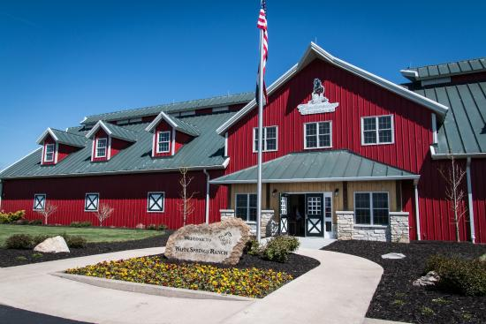
Warm Springs Ranch -
Grandparents’ Trip
Monday, June 20, 2022

You’ll start the day touring Warm Springs Ranch, the headquarters of the Budweiser Clydesdales breeding operation. You can meet and interact with the foals, mares, and stallions. Get an up-close peek at the Clydesdales’ custom-made harness, a 1903 Studebaker-built beer wagon, and luxury tractor-trailers that transport the Clydesdales to appearances all over the county. After touring Warm Springs Ranch, we head to Level Up in Columbia for lunch and an afternoon your grandkids are sure to enjoy! Here they can play laser tag, bowl, play arcade games and a high-flying indoor ropes course.
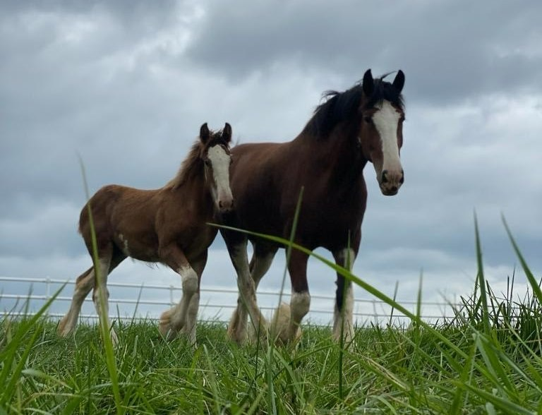
Trip cost: $135/person (sign up by June 6)

Trip includes:
- Deluxe Motorcoach Transportation
- Warm Spring Ranch Tour
- Admission to Level Up
- Lunch
- Driver Gratuities

