Mystery Trip
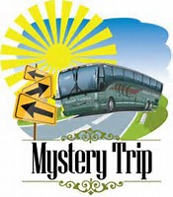
September 14, 2022

You will have an exciting day…somewhere…and fun before the trip trying to determine the destination. You’ll get clues for our destination at the Lunch and Learns, and in The Advantage Club newsletter. Enjoy the day away, and do some exploring with your Advantage Club friends!
Lunch is included in price.

Trip cost: $90/person (sign up by August 15)

