Miracle of Christmas
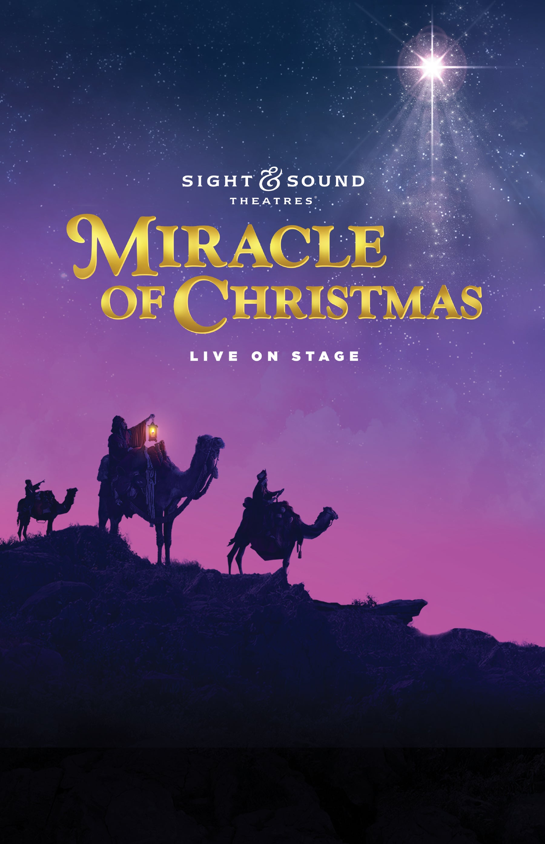
at Sight & Sound Theatre
Wednesday, December 7, 2022

Travel back in time to Bethlehem as the original Christmas story unfolds all around you. Journey alongside Mary and Joseph, a flock of surprised shepherds, and three wisemen-along with their camels! There may be no room at the inn, but God has a lowly stable prepared as the angels announce the coming of the Messiah! Experience Miracle of Christmas as it comes to life on stage with massive sets and live animals in this cherished holiday production.
Before heading to the Sight and Sound Theatre we will have lunch at Paula Deen’s and time for shopping in the specialty stores at Branson Landing.
Trip cost: $170/person (sign up by November 16)

Trip includes:
- Deluxe Motorcoach Transportation
- Miracle of Christmas Ticket
- Lunch
- Driver and Guide Gratuities

