St Louis Nibble and Nosh Food Tour -
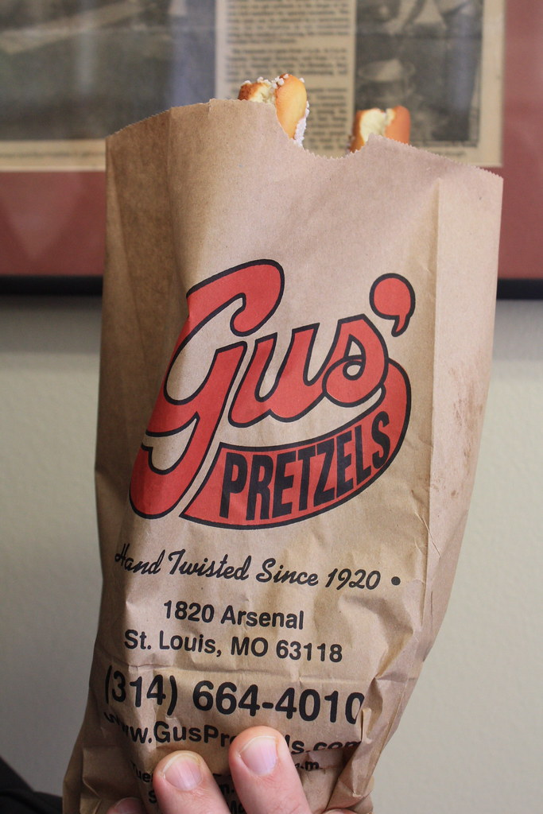
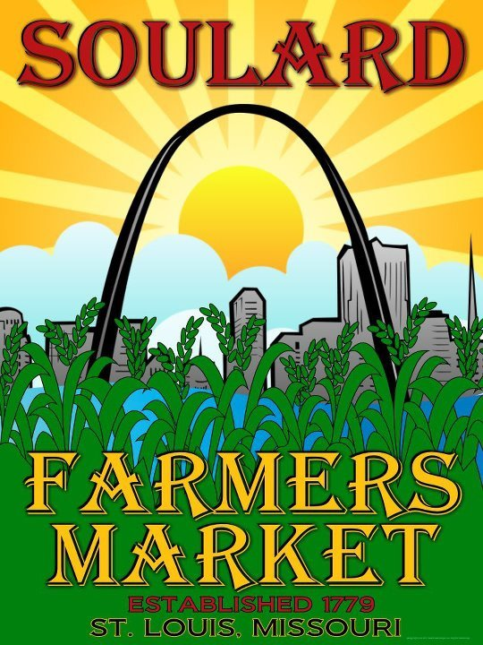
Ladies Day Out
Friday, July 22, 2022

We'll have a crazy fun-filled day driving around St. Louis to sample and purchase local edibles by famous producers with our favorite St. Louis guide Linda Koenig. Good stories too!
From the oldest farmers' market west of the Mississippi to cookies first introduced at the 1904 World's Fair in St. Louis, to the most famous frozen custard stand on all of old Route 66, there will be food and sampling all day long. Bring a big shopping bag for all your edible purchases. It’s guaranteed you won't want much for supper after this full-day 7-stop tour!
Trip cost: $95/person (sign up by July 8)

Trip includes:
- Deluxe Motorcoach Transportation
- Nibble and Nosh Tour
- Driver and Guide Gratuities

