Steamboat Arabia
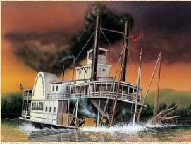
& Kansas City’s City Market
Thursday, May 12, 2022

The Arabia Steamboat Museum is one of Kansas City’s most popular attractions. Your visit to the museum is a glimpse into the past. When the Arabia sank some said she carried gold…others said fine china. What was actually discovered will amaze you. The museum has the largest single collection of pre-Civil War artifacts in the world. After touring the Arabia Steamboat Museum, enjoy lunch on your own in City Market. After lunch you can spend time browsing the shops to find unique treasures. You’ll discover apparel, jewelry, accessories, kitchen products, games, fresh flowers, gifts, home décor and many other specialty items.
Trip cost: $105/person (sign up by April 28)

Trip includes:
- Deluxe Motorcoach Transportation
- Steamboat Arabia Museum Admission
- Driver and Guide Gratuities

