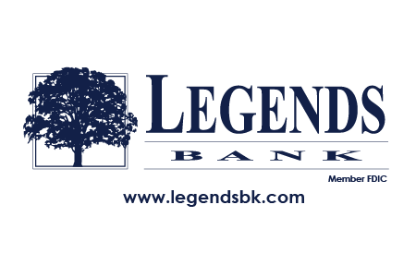

February

Celebrating 110 Years of Banking!

When: February 15, 2023
9:30 am – 1:00 pm
Where: Osage County Community Center – Linn
9:30 Coffee and Cookies
10:00 Bingo
11:00 Celebrating 110 years of Banking!
12:00 Lunch
1:00 Door Prizes

In 1913 we began as Rich Fountain Bank, in 1936 we changed our name to Linn State Bank, and over the years we’ve added the branches of Charter Bank, Tri-County Bank, Heritage Bank, and Westphalia Banking Facility. In 2005 our bank officially became known as Legends Bank.
At our February Lunch and Learn, John A. Klebba will be our speaker and will talk about the history of Legends Bank. John is Chairman of the Board and has been with the Bank since July 1991. He is the third generation in his family to serve as President of Legends Bank. John A. is the oldest son of John H. Klebba and the grandson of John B. Klebba. John holds a bachelor’s degree in accounting from Drake University, and both an MBA and a law degree from the University of Notre Dame.
Join us on February 15 as John takes you on a journey through the history of Legends Bank…just as Legends Bank gets ready to celebrate 110 years of banking!

